**COMPUTER NETWORKING**

**EXPERIMENT 1: STAR TOPOLOGY**

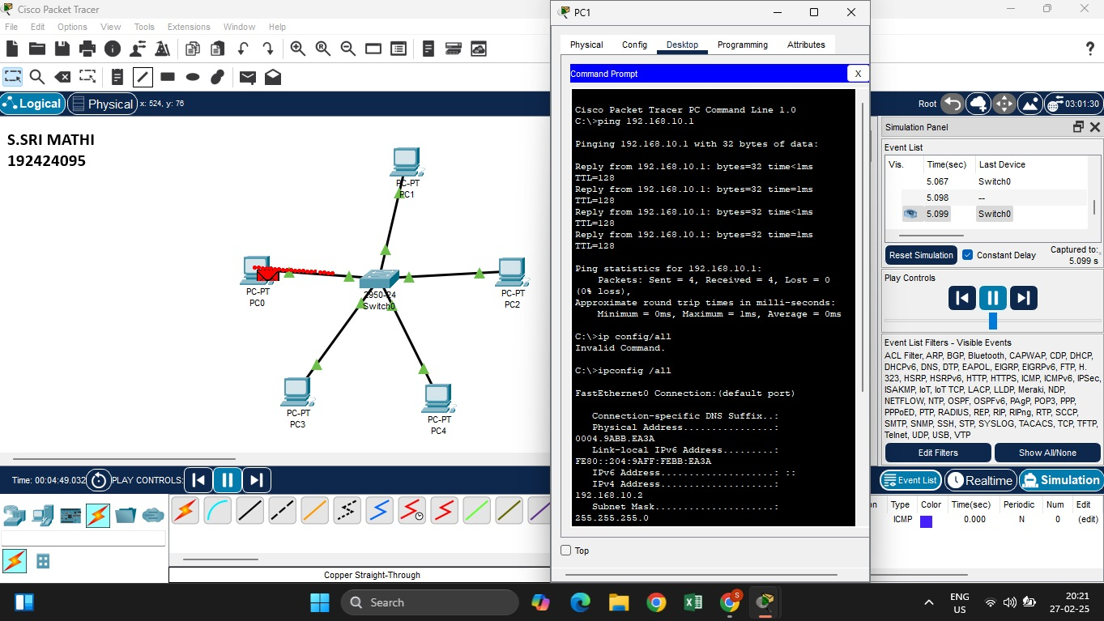

**EXPERIMENT 2 – BUS TOPOLOGY**

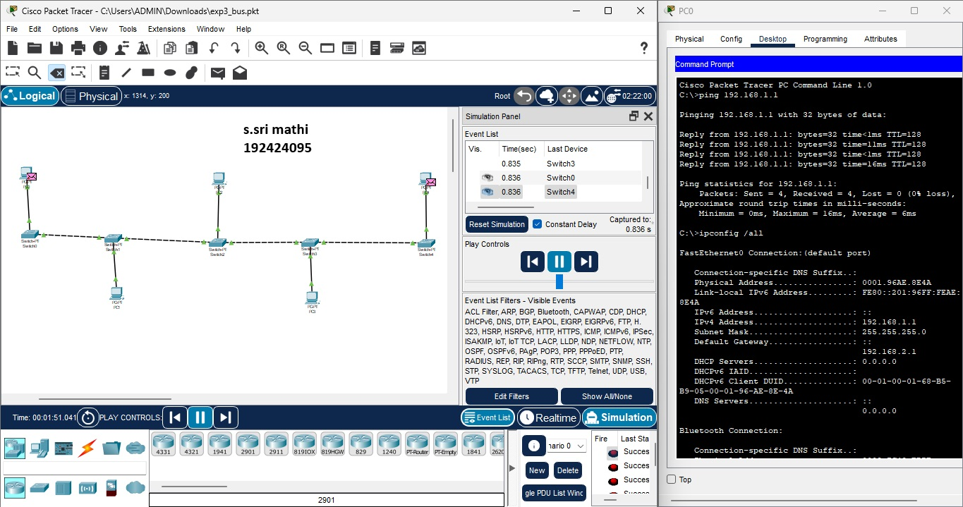

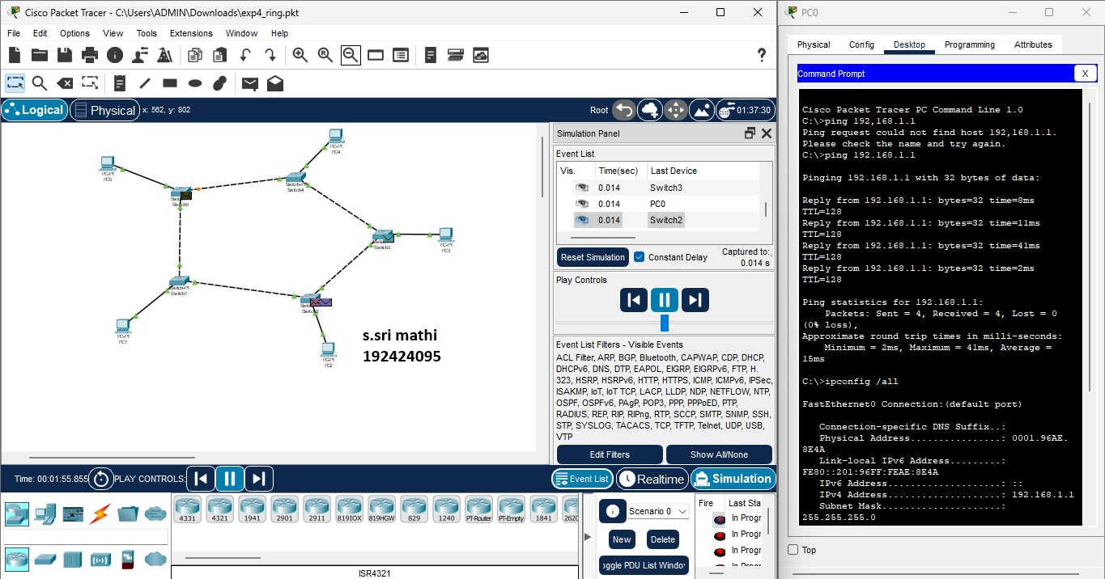

**EXPERIMENT 3 – RING TOPOLOGY**

**EXPERIMENT 4 – MESH TOPOLOGY**

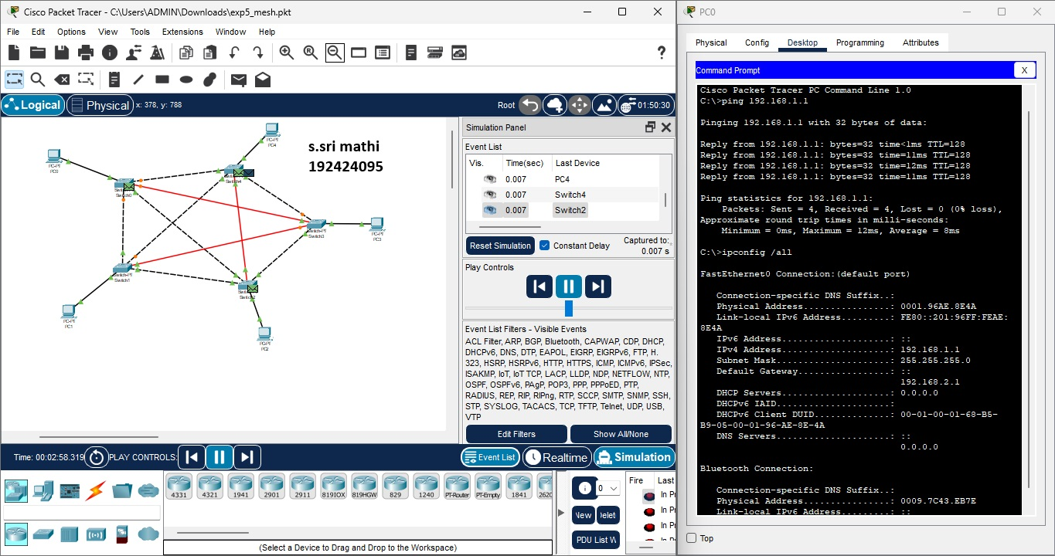

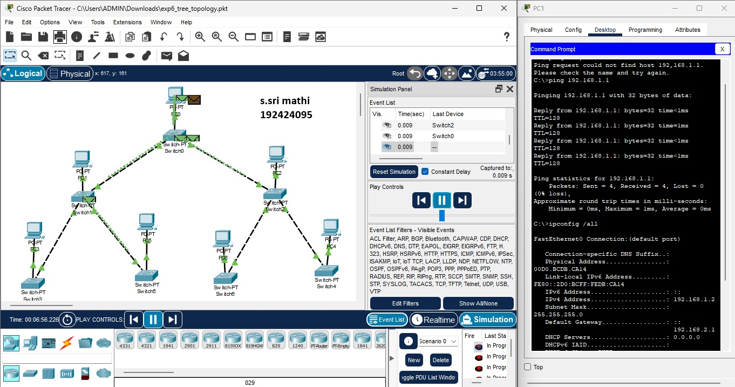

**EXPERIMENT 5 – TREE TOPOLOGY**

**EXPERIMENT 6 – HYBRID TOPOLOGY**

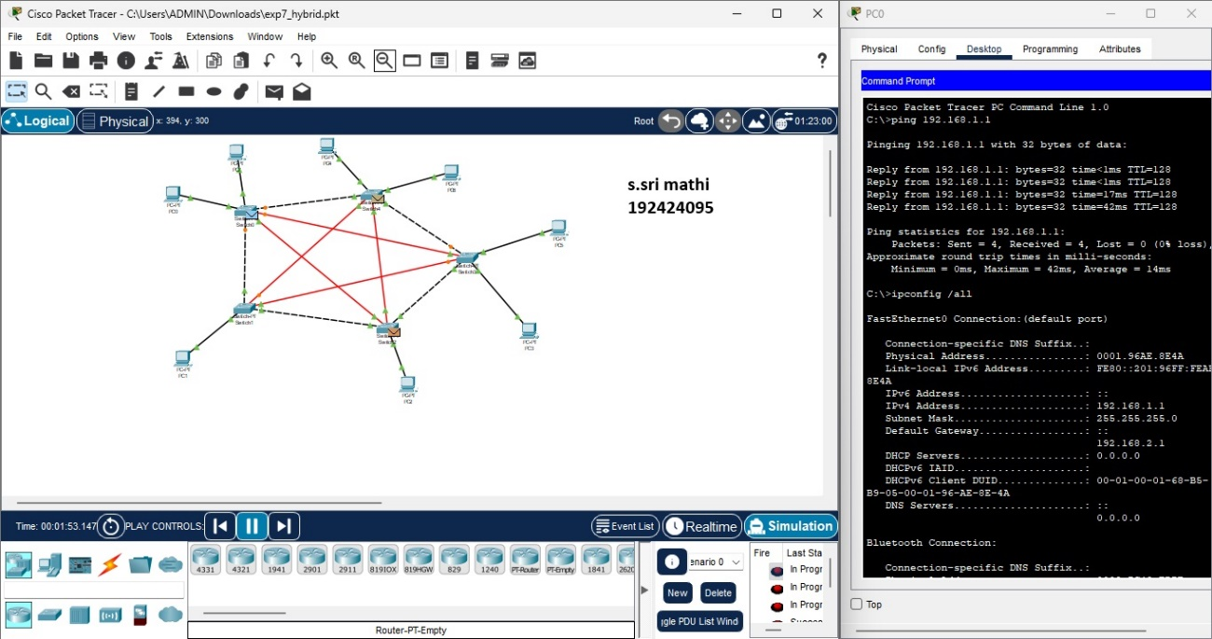

**EXPERIMENT 7 - ARP**

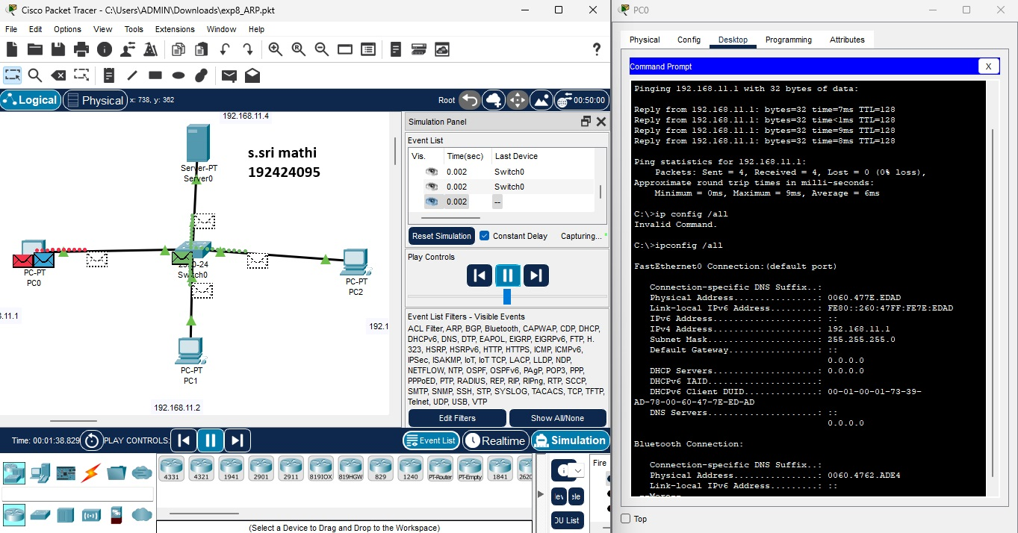

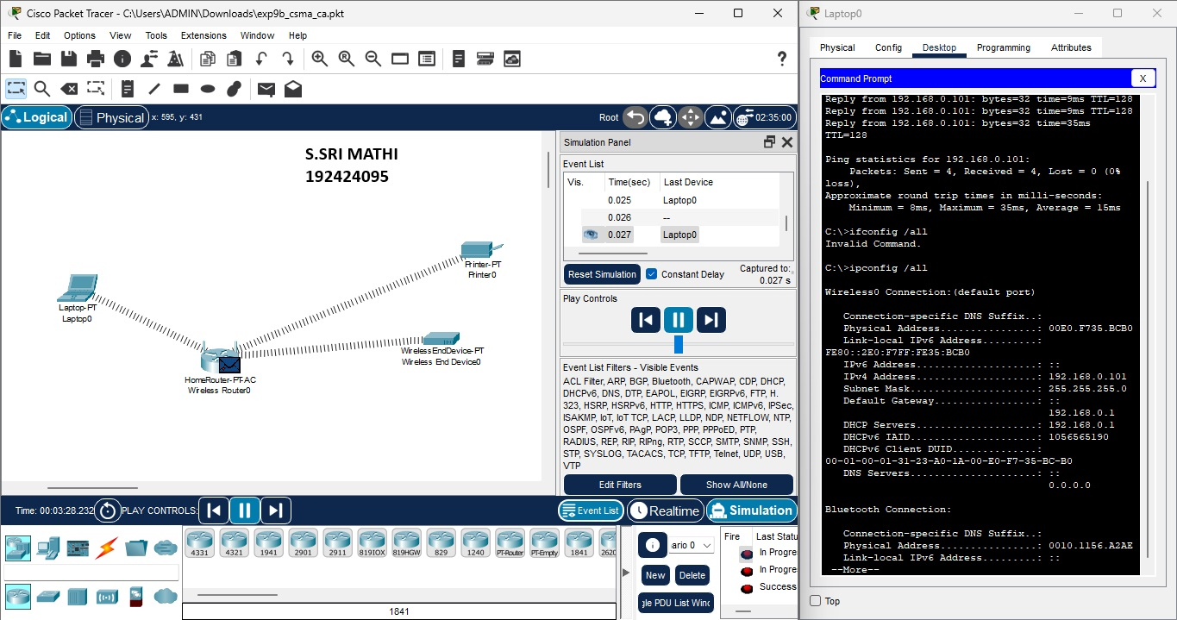

**EXPERIMENT 8 - CSMA**